## Outliers Analysis Report for Votes in Akwa Ibom

## Introduction

This report presents the results and it describes the method used in the analysis on election data in Akwa Ibom, Nigeria—the analysis aimed to identify unusual patterns in the data that may indicate potential errors or anomalies.

## Methodology for Geocoding

The Geocoding tool by Awesome Table was used to calculate the latitude and longitude of each location.

## Outlier Detection

Python libraries imported include:

‘pandas’ and ‘numpy’: They were used for data manipulation.

‘geopy.distance’ is used to calculate the geodesic distance between geographical coordinates.

The pd.read_excel was used to load the dataset into a dataframe

### Radius definition

A radius of 1.0 kilometer is defined to determine the neighborhood of each polling unit.

Compute the Geodesic Distance Matrix

A distance matrix is computed using the ‘geodesic_distance_matrix’ function which calculates the geodesic distance (the shortest distance over the earth’s surface) between each pair of polling units.

### Outlier Scores Calculation

Using the distance matrix, the neighbours within the specified radius were identified for each polling unit

Outlier scores for each party (APC, LP, PDP, NNPP) are then calculated based on the absolute difference between the party's votes at the polling unit and the average votes of its neighbors.

For polling units without neighbours, the outlier score is set to 0.

Results for each polling unit are stored in a list of dictionaries. Each dictionary contains the polling unit code, name, ward, latitude, longitude, outlier scores for each party, and the list of neighbouring polling units' codes.

The list of results is converted into a data frame.

### Sorting and Saving the Outliers:

Each party's outlier scores are sorted in descending order to identify the top 3 outliers.

The outlier scores and the top 3 outliers for each party are saved in an Excel file.

## Summary of Findings

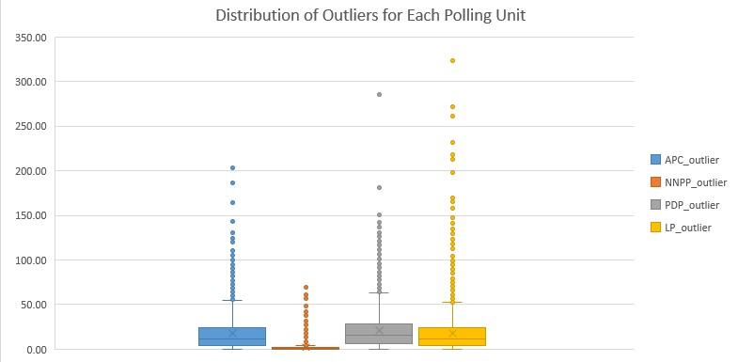

The above boxplot shows the outlier score distribution for each of the parties in the states. The outlier score is widely distributed with NNPP having the least distribution while LP has the highest distribution range. The high outlier scores show that they deviate greatly from their neighbouring polling units.

Top 3 APC Outliers and their Neighbours

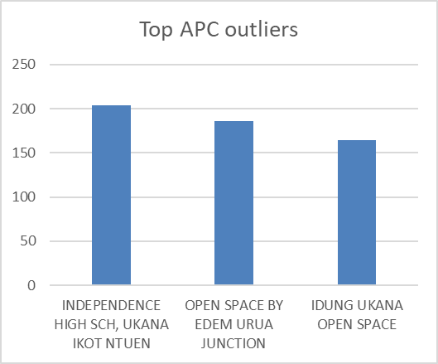

| PU-Name | Neighbours | Outlier Score |
| --- | --- | --- |
| INDEPENDENCE HIGH SCH, UKANA IKOT NTUEN | ['VILLAGE SQUARE, EKOI IKPE', 'GENERAL HOSPITAL, MBIAOBONG IKPE', 'VILLAGE SQUARE, IBAM IKPE', 'PRY SCH, UKANA UNA EAST I', 'PRY SCH, UKANA (OKOP AKAMA)', 'CLAN COUNCIL HALL, UKANA ONUK', 'IDUNG UKANA OPEN SPACE'] | 203.71 |
|  |  | 186.00 |
| OPEN SPACE BY EDEM URUA JUNCTION | ['I.C.H.S EDEM URUA', 'I.C.H.S EDEM URUA', 'VILLAGE HALL EDEM URUA'] |  |
| IDUNG UKANA OPEN SPACE | ['VILLAGE SQUARE, EKOI IKPE', 'GENERAL HOSPITAL, MBIAOBONG IKPE', 'VILLAGE SQUARE, IBAM IKPE', 'PRY SCH, UKANA UNA EAST I', 'INDEPENDENCE HIGH SCH, UKANA IKOT NTUEN', 'PRY SCH, UKANA (OKOP AKAMA)', 'CLAN COUNCIL HALL, UKANA ONUK'] | 164.29 |

Top 3 LP Outliers

| PU-Name | Neighbours | Outliers Scores |
| --- | --- | --- |
| OPEN SPACE OSONGOMA BY DOVE INT. SCH. | ['IYAMBA/ORON ROAD JUNCTION', 'VILLAGE HALL, EDEM AKAI, IKOT ESSIEN, OKON', 'OPEN SPACE MBIKPONG IKOT EDIM COMMUNITY ESTATE BY ANANA STREET', 'OPEN SPACE, ITIAM EDEM AKAI (NO. 11 HON. ARCHIBONG INYANG ST. JUNCTION)', 'OPEN SPACE BY GRACELAND SCHOOLS'] | 327.00 |
| UNIUYO ANNEX I | ['OPEN SPACE BY NO. 2 AKPAN IDIOK ST', 'EFFICIENT SEC SCH, UDO-OBIO ST', 'OPEN SPACE, UDO ABASI BY EFFIONG UKPONG ST', 'OPEN SPACE, ANUA BY OKU ST. JUNCTION', 'OPEN SPACE, NEAR NO. 17 IBIAM ST/IKOT AKPAN OKU ST', 'UDI STREET BY IKOT EKPENE RD. JUNCTION (CIVILÂ SERVICEÂ TRAININGÂ CENTRE,Â UDIÂ ST)', 'OPEN SPACE, BY NO. 20 EKPANYA ST', 'IKPA RD, BUS STOP', 'OPEN SPACE AT EPIC PLAZA, IKOT EKPENE RD', 'OLD PARK BY IKOT EKPENE RD. (OPEN SPACE)', 'OPEN SPACE NEAR COMRADE BICYCLE, IBOM CONNECTION', 'OPEN SPACE ASUTAN BY EKA ST', 'OPEN SPACE BY NO. 7, AKPABIO ST.', 'IKPA ROAD/ EKPANYA ST. JUNCTION (OPENÂ SPACEÂ NEARÂ NO.Â 37Â IKPAÂ RD)', 'UDOETTE STREET BY EBONG ESSIEN ST. JUNCTION (OPENÂ SPACEÂ NEARÂ NO.25Â UDOETTE/EBONGÂ ESSIENÂ STREET)', 'BUS STOP IKOT ABIYAK, BY CALABAR ITU ROAD', 'OPEN SPACE NO 56 IBOKO STR.', 'OPEN SPACE NO 1 OKPON STR.', 'PRIMARY SCHOOL, IKOT MBONDE', 'OPEN SPACE BY CANNAN JUNCTION MBIAKONG', 'MARKET SQUARE MBIAKONG', 'OPEN SPACE, IMO UDOEKONG STR. JUNCTION, ATAN OFFOT', 'OPEN SPACE NO 15 UDI STR.', 'OPEN SPACE MALE HOSTEL UNIUYO ANNEX', 'OPEN SPACE UDOETTE/UDOEKONG JUNCTION', 'OPEN SPACE EKA, BY ITAM STR'] | 323.15 |
| PRY SCH, ENIONG OFFOT | ['PRY SCH, IKPA IBIONO', 'OPEN SPACE, EBONG STREET EYOTONG VILLAGE', 'OPEN SPACE AT NO 27 ORON RD', 'PRY SCH, ENWE ST I', 'PRY SCH, ENWE ST II', 'STATE LIBRARY, UDOTUNG UBO ST.', 'UDO UMANA/ UDOEKPO INYANG STREET JUNCTION(PIONEERÂ NEWSPAPERÂ OFFICE,Â UDOÂ UMANAÂ ST )', 'OPEN SPACE , NSENTIP BY IMAN JUNCTION', 'UDO EDUOK/ ITIAM ST. JUNCTION (NATIONALÂ PRYÂ SCH,Â EDUÂ COMM.Â UDOÂ EDUOKÂ BYÂ ITAM)', 'QUA IBO CHURCH, BOOKSHOP AKA RD', 'UDO EDUOK BY ABAK RD. JUNCTION (INDEPENDENTÂ HALL,Â ABAKÂ RD)', 'OPEN SPACE, NEAR NO. 17 IBIAM ST/IKOT AKPAN OKU ST', 'UDI STREET BY IKOT EKPENE RD. JUNCTION (CIVILÂ SERVICEÂ TRAININGÂ CENTRE,Â UDIÂ ST)', 'OPEN SPACE AT EPIC PLAZA, IKOT EKPENE RD', 'OPEN SPACE ASUTAN BY EKA ST', 'ADULT EDUCATION CENTRE, WELLINGTON BASSEY WAY, OPP. AFRICAN CHURCH', "TRADITIONAL RULER'S COUNCIL, WELLINGTON BASSEY WAY", 'OPEN SPACE, EKPO OBOT BY UTANG ST', 'OPEN SPACE. EKPENYONG BY PAUL BASSEY ST JUNCTION', 'OPEN SPACE, UDOSEN UKO ST', 'OPEN SPACE, AKPAN ETUK BY HOSPITAL RD', 'MARKET SQUARE, MBAK AKPAN EKPEYONG', 'MARKET SQUARE, IKOT OKUBO OFFOT', 'PRY SCH, NSUKARA OFFOT', 'PRY SCH, MBIABONG IKONO', 'MARKET SQUARE, NDUETONG OKU', 'OPEN SPACE, ITA ETUK STREET JUNCTION', 'CIVIC CENTER, ENIONG OFFOT. UYO', 'EKPRI NSUKARA OFFOT INT. SCHL', 'OPEN SPACE NO. 15 UDOEKPO INYANG STR. BY UDOTUNG UBO JUNCTION', 'OPEN SPACE NO. 15 UDOEKPO INYANG STR. BY UDOTUNG UBO JUNCTION', 'OPEN SPACE NO. 15 UDOEKPO INYANG STR. BY UDOTUNG UBO JUNCTION', 'OPEN SPACE NO. 15 UDOEKPO INYANG STR. BY UDOTUNG UBO JUNCTION', 'OPEN SPACE BY FORMER MR. BIGGS, DOMINIC UTUK AVENUE', 'OPEN SPACE UTANG STREET, OPP. AIRTEL MAST.', 'OPEN SPACE, SAMPSON SAMPSON BY UTANG STR.', 'OPEN SPACE, NO 20 ORON ROAD', 'OPEN SPACE BY 37, EKPENYONG STREET.', 'OPEN SPACE BY 12 UDO OBOT STREET', 'OPEN SPACE RAVINE PARK, DOMINIC UTUK AVENUE', 'OPEN SPACE BY CANNAN JUNCTION MBIAKONG', 'MARKET SQUARE MBIAKONG', 'TOWN HALL, NSUKARA OFFOT', 'OPEN SPACE NO 15 UDI STR.', 'OPEN SPACE EKA, BY ITAM STR', 'OPEN SPACE OKOKON ETUK STR. BY UDOK JUNCTION'] | 272.24 |

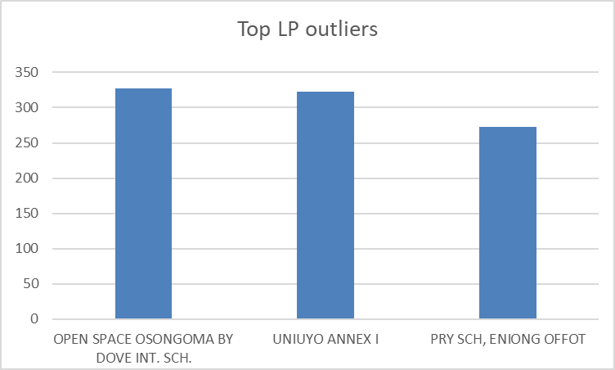

| PU-Name | Neighbours | Outlier_scores |
| --- | --- | --- |
| OPEN SPACE BY TOWN HALL ASSANG, ALONG ATABONG ROAD, ADJACENT QUA IBOE CHURCH. | ['TOWN HALL ATABONG. I', 'TOWN HALL ATABONG. II', 'V/H IDUNG UDOFA', 'V/H IDUNG USO', 'USUNG INYANG COMMUNITY CENTRE I', 'USUNG INYANG COMMUNITY CENTRE II', 'PRY SCH USUNG INYANG', 'TOWN HALL ASSANG', 'GOVT PRY SCH IKOT EBIYAN', 'TOWN HALL ETEBI IDUNG AKPAISANG', 'GOVT PRY SCH, IKOT EBOK', 'PRY SCH, IKOT ABASI I', 'PRY SCH, IKOT ABASI II', 'VILLAGE HALL, IKOT UKPONG BESIDE THE SANCTIFIED MOUNT ZION CHURCH, IKOT UKPONG.', 'OPEN SPACE 1, ATABONG BESIDE THE APOSTOLIC CHURCH, IDUA ROAD', 'OPEN SPACE II, ATABONG BESIDE THE APOSTOLIC CHURCH, IDUA ROAD.', 'OPEN SPACE, ATABONG ROAD OPPOSITE THE APOSTOLIC CHURCH.', 'CIVIC CENTRE IDUNG UDOFA, BESIDE THE APOSTOLIC CHURCH, UDOFA STREET.', 'OPEN SPACE ABAKATIP, OTU SQUARE, ADJACENT SEVENTH DAY ADVENTIST CHURCH, UDOFA AVENUE.', 'A.M.E ZION PRIMARY SCH.USUNG INYANG BESIDE THE CHOSEN CHURCH BY URUA OFFIONG ETUK.', 'OPEN SPACE BY COMMUNITY CENTRE ALONG ASANG STREET, ADJACENT ASSEMBLIES OF GOD CHURCH, USUNG INYANG', 'OPEN SPACE IN FRONT OF AKS WATER COMPANY, OPPOSITE ST. GREGORY PRIMARY SCH. ALONG ST.GREGORY ROAD, USUNG INYANG', 'OPEN SPACE SILENT ZONE JUNCTION BY MARKET ROAD, USUNG INYANG.', 'MODERN MOTOR PARK, OPPOSITE CHINA MARKET ALONG PARK ROAD.', 'VILLAGE HALL, OKUKWOT, ADJACENT FOURSQUARE GOSPEL CHURCH BY ETEBI STREET.', 'MARKET SQUARE AFFIONG ETUK, OPPOSITE QUA IBOE CHURCH IDUA ROAD, ASSANG', 'OPEN SPACE BY EBENEBE TOWN HALL, ALONG ASSANG RING ROAD.', 'OPEN SPACE BY UBANG CRESCENT OFF ATABONG ROAD, ASSANG OPPOSITE AFFIONG ETUK MARKET SQUARE.', 'GOVERNMENT PRIMARY SCH. IKOT EBIYAN, ALONG HOSPITAL ROAD.', 'YOUTH & WOMEN HALL, BESIDE ETEBI IDUNG AKPAISANG VILLAGE HALL, ETEBI STREET.', 'OPEN SPACE BY VILLAGE TRIANGLE, OPPOSITE ETEBI IDUNG AKPAISANG VILLAGE HALL, ALONG ETEBI STREET.', 'GOVERNMENT PRIMARY SCH. IKOT EBOK, OPPOSITE AKS WATER COMPANY ALONG ST. GREGORY ROAD', 'OPEN SPACE BY CIVIC CENTRE BESIDE LIVING FAITH CHURCH ALONG LIVERPOOL ROAD', 'VILLAGE HALL, AFAHA UQUA BESIDE THE APOSTOLIC CHURCH BY AFAHA UQUA ROAD'] | 285.15 |
| PRY SCH, IMAN | ['PRY SCH, OBOM', 'VILLAGE SQUARE, ATAN', 'CENTRAL VILLAGE SQUARE, OKON', 'JUDICIARY DISTRICT COURT, UKPUM OKON'] | 181.50 |
| PRY SCH, IKOT EKPENE UDO | ['SEC SCH, IKOT EKPENE UDO', 'TOWN HALL, IKOT EKPENE UDO', 'COTTAGE HOSPITAL, IKOT EKPENE UDO.'] | 181.00 |

Top 3 Outliers for PDP

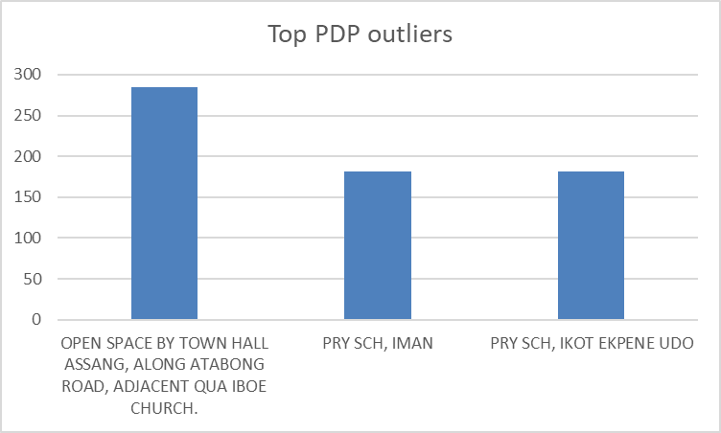

Top 3 NNPP Outliers

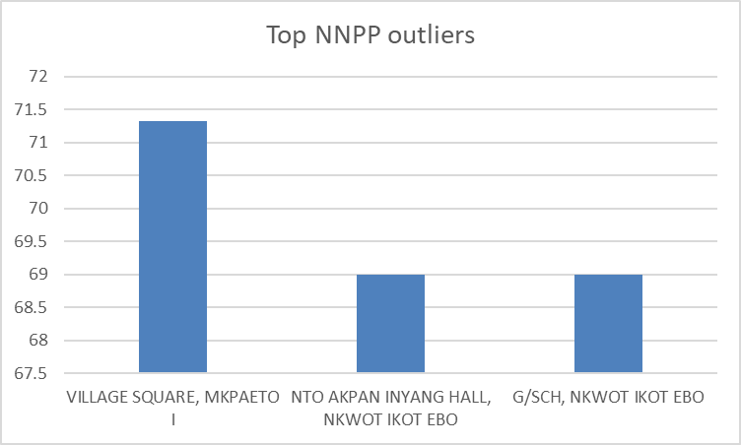

| PU-Name | Neighbours | Outlier_scores |
| --- | --- | --- |
| VILLAGE SQUARE, MKPAETO I | ['VILLAGE SQUARE, MKPAETO II', 'TOWN HALL, IKOT EKO IBON', 'VILLAGE SQUARE, IKOT EKO IBON'] | 71.33 |
| NTO AKPAN INYANG HALL, NKWOT IKOT EBO | ['G/SCH, NKWOT IKOT EBO'] | 69.00 |
| G/SCH, NKWOT IKOT EBO | ['NTO AKPAN INYANG HALL, NKWOT IKOT EBO'] | 69.00 |

Conclusion

The geospatial analysis shows the Outlier scores of each polling unit and the high outlier scores suggest irregularities in the voting process. Labour party had the most irregularities in the state since it has the highest outlier scores.